**Online Appendix**

**Online Appendix to Chapter 1**

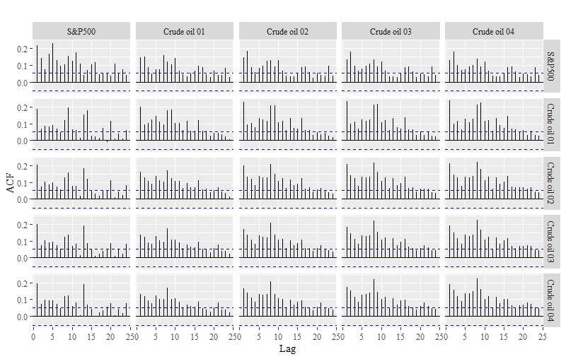

Fig: ACF of S&P500 and crude oil futures squared return series

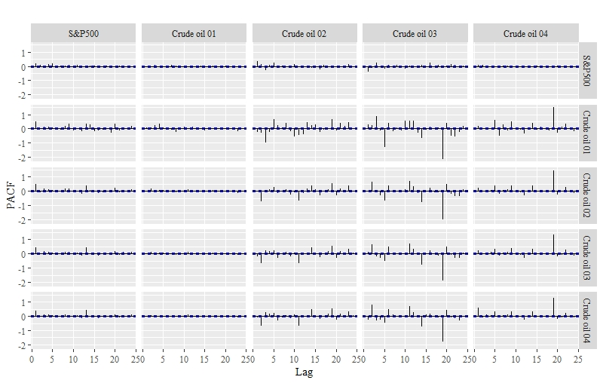

Fig: PACF of S&P500 and crude oil futures squared return series

**Various linkage among variables:**

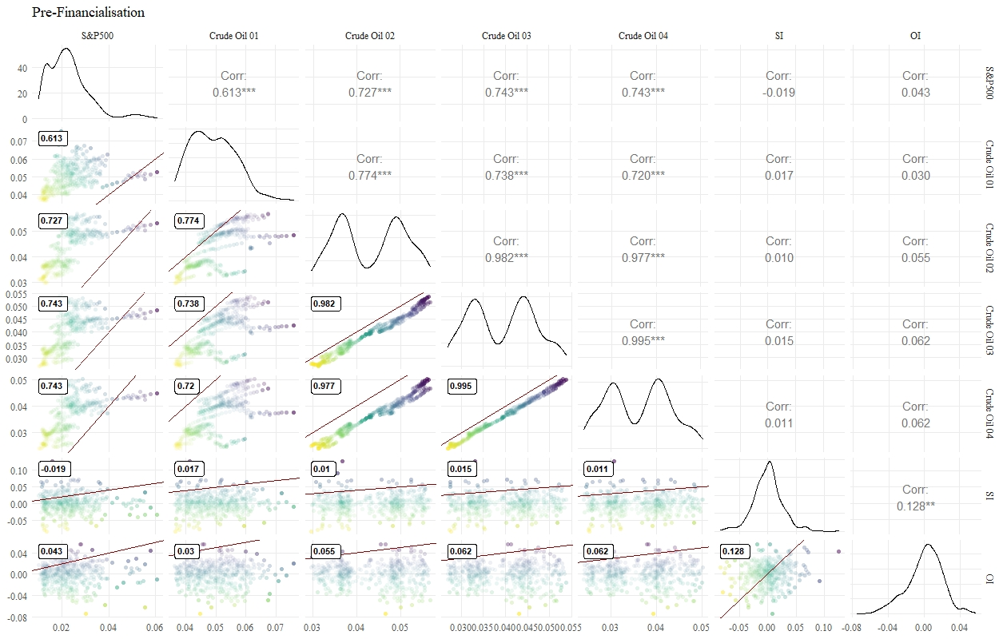

Fig: Correlation between conditional volatility, speculation index and open interest (Pre-Financialisation)

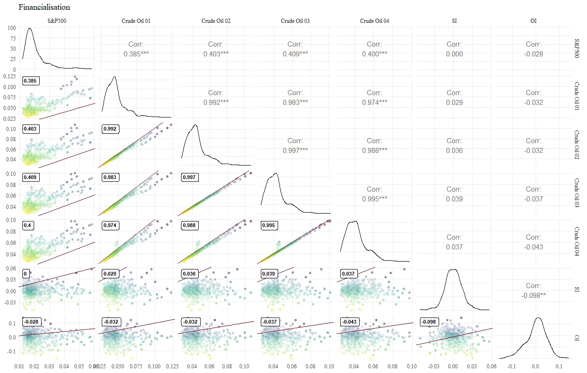

Fig: Correlation between conditional volatility, speculation index and open interest (Financialisation)

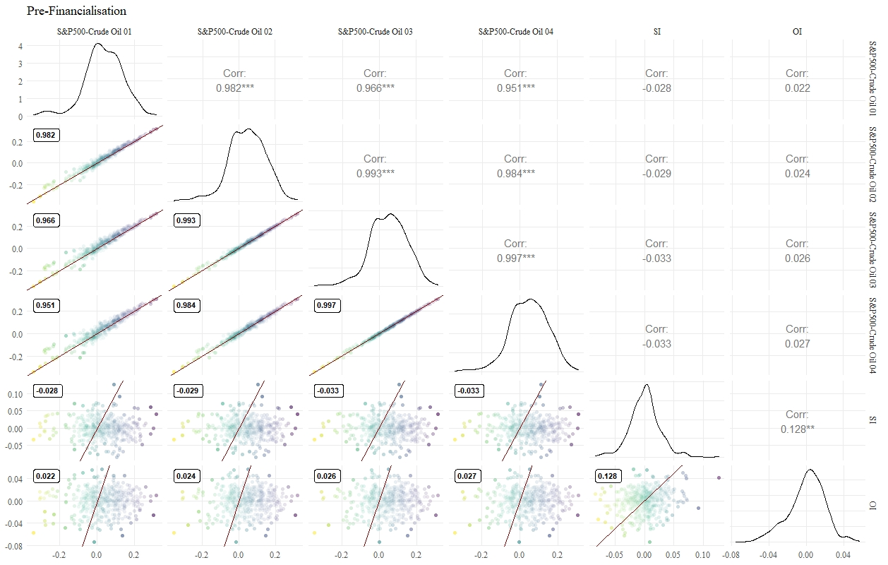

Fig: Correlation between conditional correlation, speculation index and open interest (Pre-Financialisation)

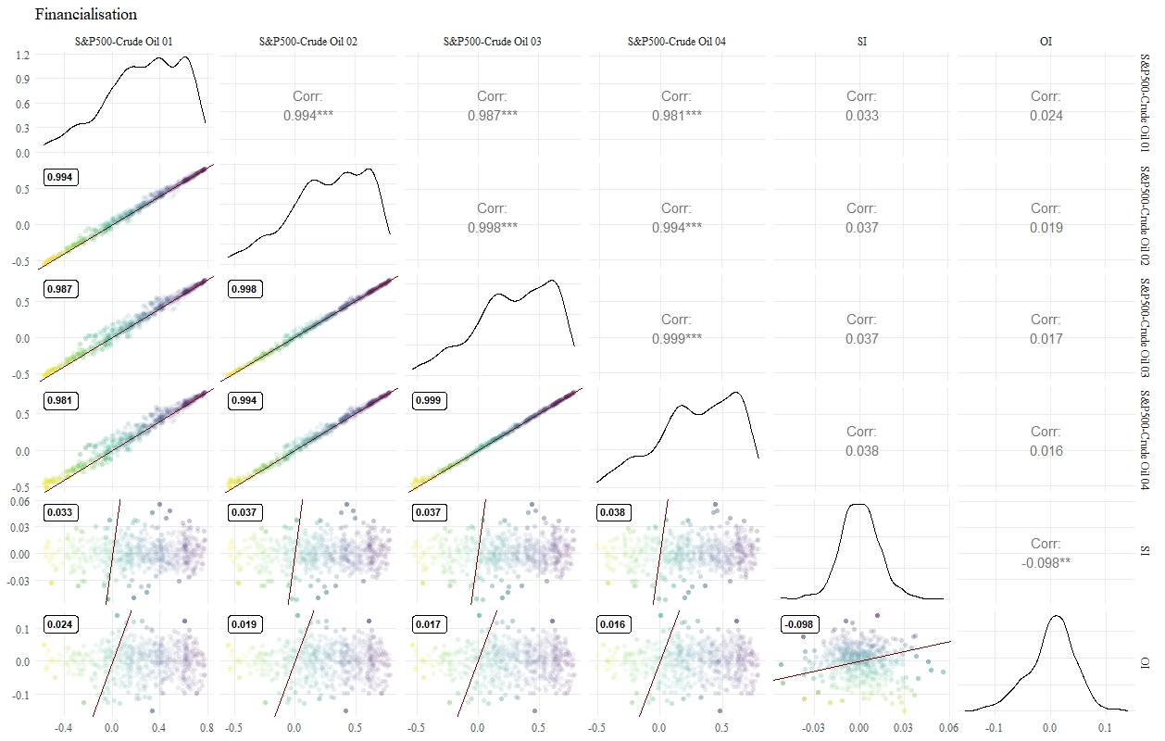

Fig: Correlation between conditional correlation, speculation index and open interest Financialisation)

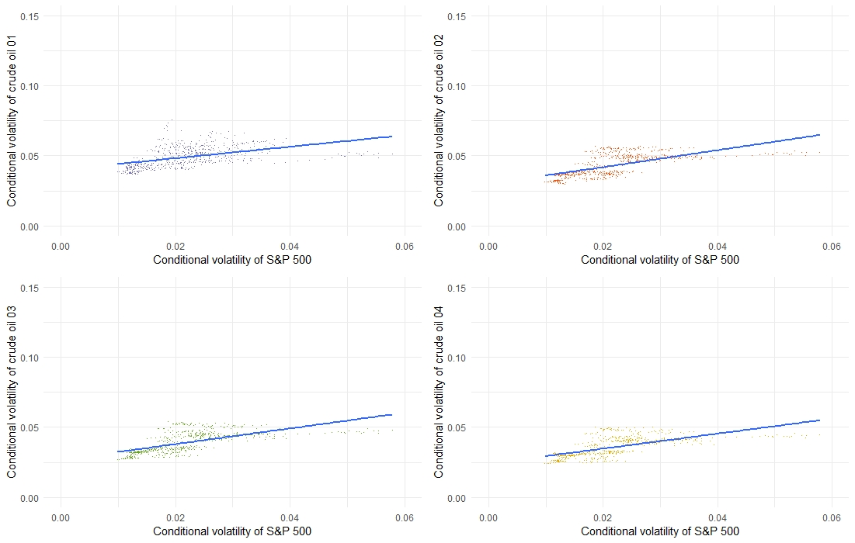

Fig: Conditional volatility of S&P500 vs conditional volatility of crude oil futures (Pre-Financialisation)

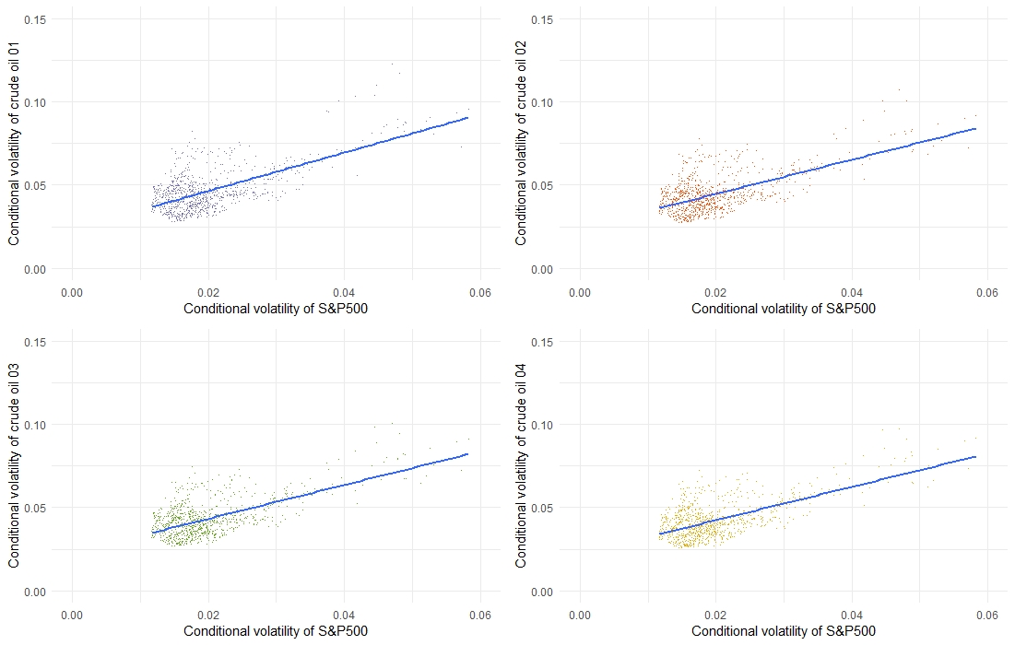

Figure: Conditional volatility of S&P500 Index vs conditional volatility of crude oil futures (Financialisation)

**Online Appendix to Chapter 3**

**Online Appendix to Chapter 4**

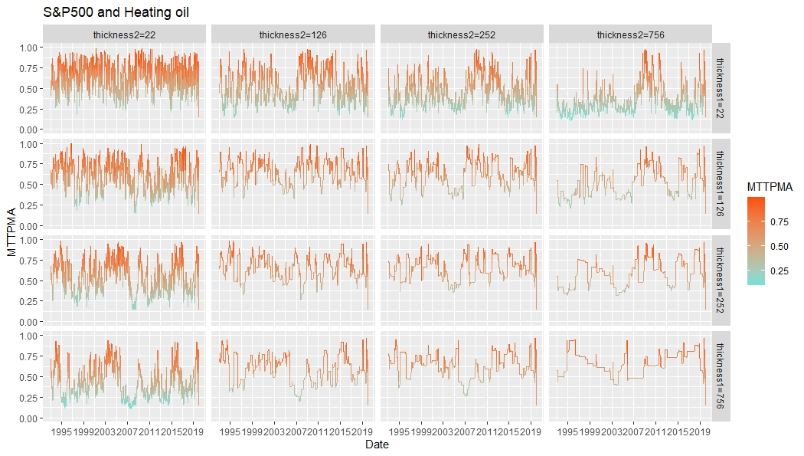

Figure: TPMA and MTTPMA of S&P500 Index and heating oil

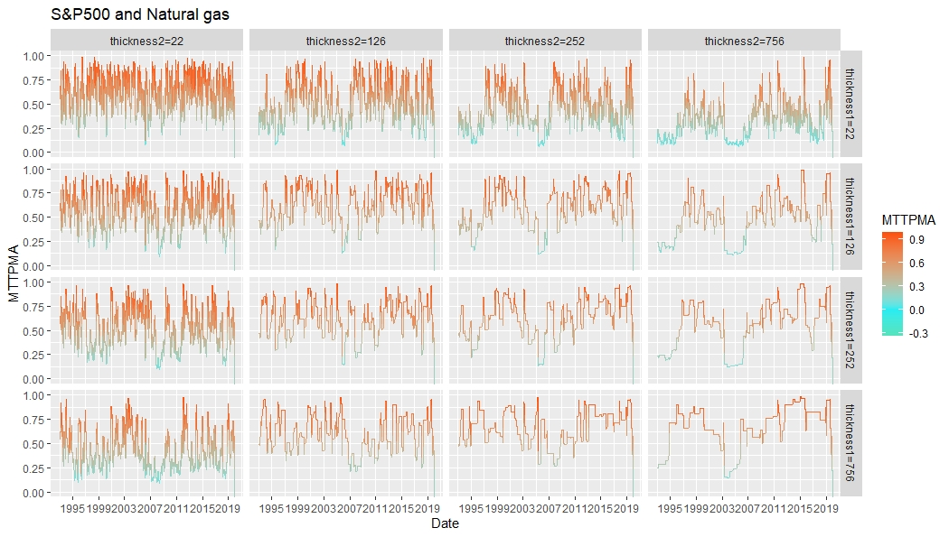

Figure: TPMA and MTTPMA of S&P500 Index and natural gas

Figure: TPMA and MTTPMA of S&P500 Index and heating oil